**Supplemental formulas：**

**Supplemental formula 1: The detailed process to obtain enhanced association matrix****by using EASNN:**

Firstly, using  to obtain suitable location: sort the similarity interaction profile  () in descending order and search backwards from the first point until a positionthat satisfies the following conditions is found:



where  is the step length, which is generally set at one-fifth of the length of.

Secondly, for each similarity matrix, a new matrix  and  are obtained:





Thirdly, andcombine with the association matrixto obtain a new interaction profile:







where () to () are sorted in descending order by their similarity to (), , , 

Finally, using the new interaction profileto update the original miRNA-disease associations matrix:



Supplemental formula 2: The specific formula of each performance evaluation metric to measure the prediction performance of DMFVAE:













where  represents true positive,  represents true negative,  represents false positive,  represents false negative.  and  represent true positive rate and false positive rate, according to them, the ROC curve is obtained, and the corresponding area is AUC. Similarly, AUPR is obtained according to precision and recall.

**Supplemental Figures：**

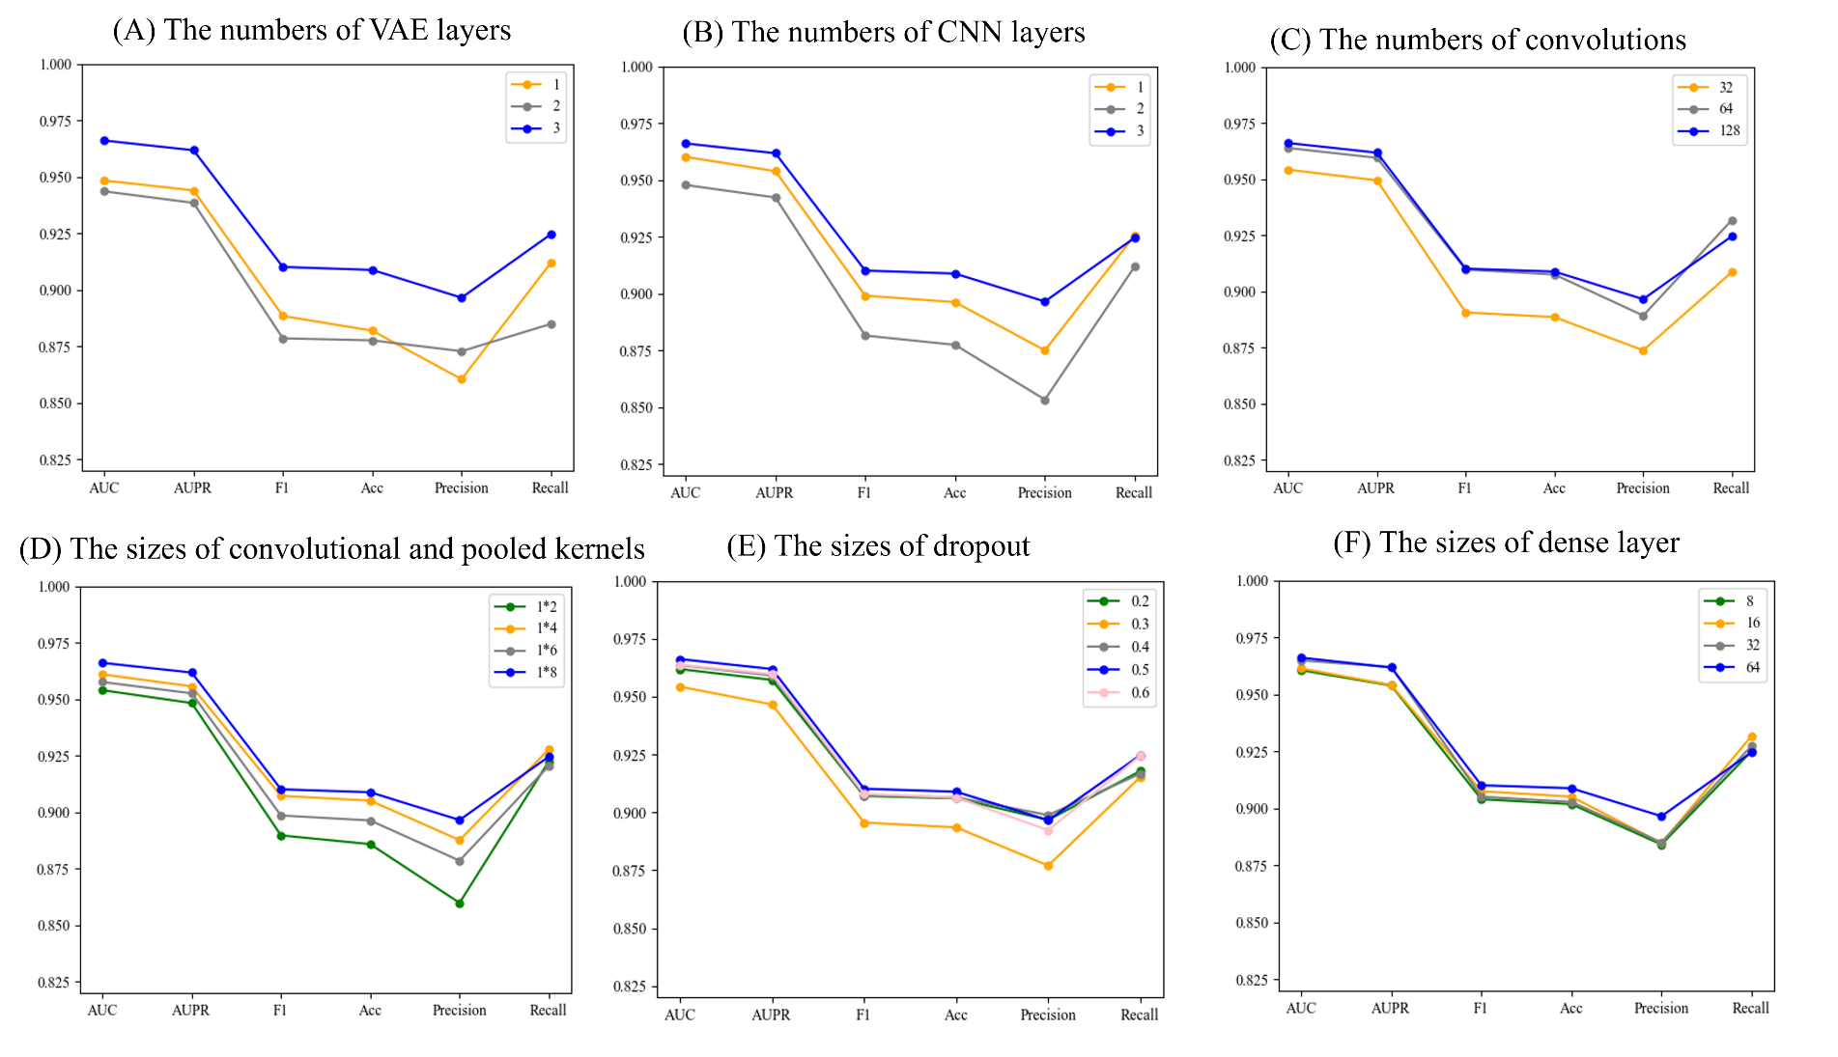

**Supplemental Fig S1. The detailed parameters tuning experiments on HMDD v2.0 balanced datasets. The F1 and Acc representF1-score and accuracy, respectively**

**Supplemental Tables：**

Supplement Table S1-S2: The individual values of the evaluation indicators on HMDD v2.0 dataset. For balanced dataset, the average value is calculated from AUC, AUPR, F1 and Acc. For unbalanced dataset, the average value is calculated from AUPR and F1:

Supplement Table S1. DMFVAE compared with other models on balanced dataset

|  |  |  |  |  |  |  |  |
| --- | --- | --- | --- | --- | --- | --- | --- |
| models | AUC | AUPR | F1 | Acc | Precision | Recall | Avg |
| SMALF | 0.9503 | 0.9472 | 0.8868 | 0.8860 | 0.8808 | 0.8931 | 0.9176 |
| ERMDA | 0.9013 | 0.9043 | 0.8356 | 0.8300 | 0.8096 | 0.8639 | 0.8678 |
| VAEMDA | 0.9206 | 0.9215 | 0.8466 | 0.8382 | 0.8045 | 0.8938 | 0.8817 |
| GRPAMDA | 0.9346 | 0.9331 | 0.8606 | 0.8600 | 0.8579 | 0.8637 | 0.8971 |
| DMFVAE | 0.9662 | 0.9619 | 0.9102 | 0.9089 | 0.8966 | 0.9247 | 0.9368 |

Supplement Table S2. DMFVAE compared with other models on unbalanced dataset

|  |  |  |  |  |  |  |  |
| --- | --- | --- | --- | --- | --- | --- | --- |
| models | AUC | AUPR | F1 | ACC | Precision | Recall | Avg |
| MDA-GCNFTG | 0.9448 | 0.6137 | 0.5080 | 0.9718 | 0.6324 | 0.5628 | 0.5609 |
| GBDT-LR | 0.9397 | 0.4816 | 0.6688 | 0.9757 | 0.3029 | 0.4168 | 0.5752 |
| NIMGSA | 0.9354 | 0.4567 | 0.4346 | 0.9721 | 0.5229 | 0.3518 | 0.4457 |
| GAEMDA | 0.9321 | 0.4432 | 0.6836 | 0.9748 | 0.2262 | 0.3382 | 0.5634 |
| DMFVAE | 0.9678 | 0.6556 | 0.6055 | 0.9802 | 0.7053 | 0.5313 | 0.6306 |

Supplement Table S3-S4: The individual values of the evaluation indicators on HMDD v3.2 dataset. For balanced dataset, the average value is calculated from AUC, AUPR, F1 and Acc. For unbalanced dataset, the average value is calculated from AUPR and F1:

Supplement Table S3. DMFVAE compared with other models on unbalanced dataset

|  |  |  |  |  |  |  |  |
| --- | --- | --- | --- | --- | --- | --- | --- |
|  | AUC | AUPR | F1 | Acc | Precision | Recall | Avg |
| ABMDA | 0.9152 | 0.9069 | 0.8402 | 0.8439 | 0.8398 | 0.8479 | 0.8766 |
| VGAMF | 0.9443 | 0.9397 | 0.8764 | 0.8763 | 0.8754 | 0.8775 | 0.9092 |
| MLRDFM | 0.9545 | 0.9550 | 0.8833 | 0.8833 | 0.8833 | 0.8834 | 0.9190 |
| DMFVAE | 0.9682 | 0.9639 | 0.9140 | 0.9123 | 0.8967 | 0.9322 | 0.9396 |

Supplement Table S4. DMFVAE compared with other models on unbalanced dataset

|  |  |  |  |  |  |  |  |
| --- | --- | --- | --- | --- | --- | --- | --- |
|  | AUC | AUPR | F1 | Acc | Precision | Recall | Avg |
| VGAMF | 0.9260 | 0.5217 | 0.40437 | 0.9748 | 0.7338 | 0.28796 | 0.4630 |
| MLRDFM | 0.9311 | 0.5387 | 0.4228 | 0.9757 | 0.7630 | 0.2928 | 0.4808 |
| DMFVAE | 0.9705 | 0.6853 | 0.6191 | 0.9795 | 0.7142 | 0.5514 | 0.6522 |

**Supplement Table S5. Top 20 candidate miRNAs associated with CN, where H3, DEMC and miR represent HMDD v3.2, DEMCDEMC and miR2Disease respectively**

|  |  |  |  |
| --- | --- | --- | --- |
| miRNA name | evidence | miRNA name | evidence |
| hsa-mir-483 | DEMC | hsa-mir-19a | HM, DEMC, miR |
| hsa-mir-135a | DEMC, miR | hsa-mir-125b | DEMC |
| hsa-mir-141 | DEMC, miR | hsa-mir-302b | DEMC, HM |
| hsa-mir-20b | DEMC, miR | hsa-mir-125a | DEMC, miR |
| hsa-mir-146a | HM, DEMC, miR | hsa-mir-155 | DEMC, miR |
| hsa-mir-196a | HM, DEMC, miR | hsa-mir-199b | DEMC |
| hsa-mir-31 | DEMC | hsa-mir-20a | DEMC, miR |
| hsa-mir-34a | DEMC, miR | hsa-mir-21 | HM, DEMC, miR |
| hsa-let-7a | DEMC, miR | hsa-mir-182 | DEMC, miR |
| hsa-mir-148a | DEMC | hsa-mir-143 | HM, DEMC, miR |

**Supplement Table S6. Top 20 candidate miRNAs associated with EN, where H3, DEMC and miR represent HMDD v3.2, DEMCDEMC and miR2Disease respectively**

|  |  |  |  |
| --- | --- | --- | --- |
| miRNA name | evidence | miRNA name | evidence |
| hsa-mir-23a | DEMC | hsa-mir-124 | DEMC |
| hsa-mir-125a | DEMC | hsa-mir-10b | DEMC |
| hsa-mir-7 | DEMC, miR | hsa-mir-182 | DEMC |
| hsa-mir-20b | DEMC, miR | hsa-mir-224 | DEMC |
| hsa-mir-200b | DEMC | hsa-mir-142 | DEMC |
| hsa-mir-708 | DEMC, miR | hsa-mir-199b | DEMC |
| hsa-mir-122 | PMID: 22751839 | hsa-mir-10a | DEMC |
| hsa-mir-16 | DEMC | hsa-mir-378a | DEMC |
| hsa-mir-135a | DEMC | hsa-mir-133b | DEMC, HM |
| hsa-mir-19b | DEMC | hsa-mir-125b | DEMC |